Term Paper

Face Fusion: An Automatic Method for Virtual Plastic Surgery

Sudipta Paul
Roll no. : 91/CIS/091014
Registration no: 0054377 Of 2006-07

Under the Guidance of
Prof. S.K.Bondhopadhyay
Computer science & Engg. Dept. C.U

Abstract
This work describes a system that replaces an individual's facial features with corresponding features of another individual possibly of different skin color and fuses the replaced features with the original face, such that the resulting face looks natural. The final face resulting from the fusion of the original face with exogenous features lacks the characteristic discontinuities that would have been expected if only a replacement operation was performed. The proposed system could be used to simulate and predict the outcome of aesthetic maxillofacial plastic surgeries. To achieve its task, the system uses five modules: face detection, feature detection, replacement, shifting and blending. While these modules are designed to address the problem of face fusion, some of the novel algorithms and techniques introduced in this work could be useful in other image processing and fusion applications.

About Plastic surgery:
It is a medical specialty concerned with the correction or restoration of form and function of different body part. Though cosmetic is the best-known kind of plastic surgery, most plastic surgery is not cosmetic: plastic surgery includes many types of reconstructive surgery, and the treatment of burns. Aulus Cornelius Celsus, who lived in the first century AD, described plastic surgery of the face, using skin from other parts of the body.

Reason of popularity:
It can reconstruct the human body part which has an ugly scar due to some accident such as burn impression.
Some people may not be satisfied with their natural face. Plastic surgery may be a solution for their frustration.
Definition of Face Fusion:
It replaces an individual’s facial feature with corresponding features of another individual may be different skin colour. The resulting face may have discontinuities and may not look natural.
So only replacement operation is not the solution.

Example:
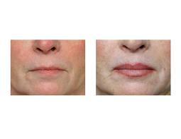
In the above figure replacement of lip is performed.

Virtual Plastic Surgery:
It is the process by which the resultant face should appear after the surgery.
This virtual surgery process helps a lot in removing the discontinuity of the face that may occur if the face is not predicted.

Overview:
It takes the two faces as input from that the user has to input -by clicking- the approximate coordinate of the tip of the nose belonging to the face of interest. As will be discussed in subsequent sections, this additional information will be used to find the face in an image, as well as giving an idea of the skin color for each face. The first step is to detect faces in the input images. The face detection module achieves this goal by using a stored template of a generic face. Once the face is detected, the feature detection module finds three rectangular regions containing the left eye, the right eye and the lips. This information is then fed into the replacement module which replaces the eyes and lips of the original face with those of the model face. Together, the shifting and blending modules achieve smooth blending of the replaced features in the original face, such that the result will look natural.

Five Modules:
- Face detection
- Feature detection
- Replacement
- Blending
- Shifting

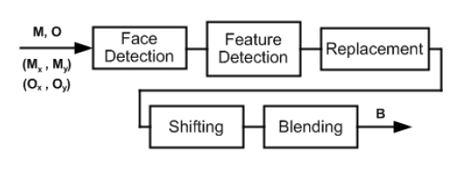
Figure 1.

Figure 1 shows the pictorial view of all the modules. M is the model image, O is the original image, (M_{x}, M_{y}) is the coordinate of the nose tip of the model face and (O_{x}, O_{y}) is the same for the original image.

Face Detection

The overall process can be described as follows,
- User gives input by clicking the coordinate of the nose tip belonging to the face of interest.
- Previous diagram shows the input.
- M is the model image, O is the original image, (M_{x} ,M_{y} ) is the coordinate of the tip of the nose for the model image 1 (O_{x} , O_{y} ) is same for original image.
- A template is placed on the face which is enlarging in small interval.

- Following transformation on the image is performed 1st.
F: M^{m*n*3} à T^{m*n*1}
Such that

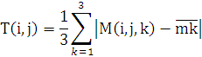

- Here M(i,j,k) gives the values of the pixel in the ith row & jth column.
- T is the resulting image.
- Value subtracted is the mean RGB value for the 10X10 pixel array centered on nose tip.
- Now the next step to be performed,

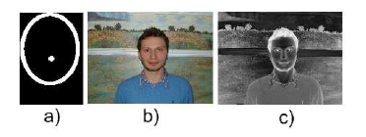

- Fig-a shows the face template.
- Fig-b shows the face before transformation.
- Fig-c shows the face after transformation. Colour different from skin will look lighter & colour similar to skin will look darker.

Superimposing the face template:

Figure 2.

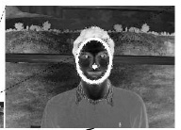

- I (sum of the intensities of pixel in T that lie on the boundary of the face template) is small when the template is small.

- A sudden increase in I value occur when template lies completely outside the face boundary. This is used to detect the face location. Shown in the figure 2.

- Once the face position in the image is detected now the features of the face to be detected.

Feature Detection

- From homology of human face the rectangular box can be found as in the figure 3.
- Considering eyes let the box is L_{x} X L_{y} . Say E.
- To pin point location of the eyes more accurately.

Figure 3.

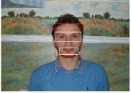

- To find two l_{x} X l_{y} boxes pin pointing two eyes.
- At first edge detection to be performed on left figure which is E.

Figure 4.
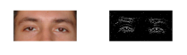

- Figure 4 will be found and as we approaches the eye more edge will be visible.
- For each column along the length of E, sum of the edges to be found.
H(i)=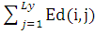
Where 1<=i <= L_{x} and Ed is the image representing the edges in the eye box of size L_{x} X L_{y} . Peaks are found around the location of the eyes.
Same to be performed on vertical direction but this time summing the edges in each row instead of each column.

Figure 5.
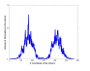

In figure 5 the graph is given for summing up the edges along each column. Along X axis it is X-coordinate value for the columns and along the Y-axis it the amount of information in the column.

- Now to find two equal interval one on each side of the face. Length of the interval is l_{x} .

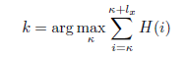
- Here k<=i<=k+l_{x} , is the horizontal edge of the left eye box or right eye box. Depending on where the equation is performed, left or right.

- The horizontal and vertical interval for which the projected area is maximum from the horizontal and vertical edges for the eye box.

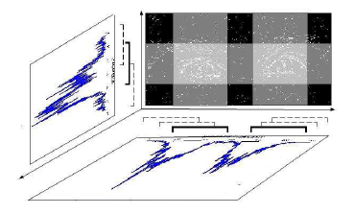
Figure 6.

In figure 6 the maximum projected area is shown and this is the location of the eyes.
This will be the final output of the feature detection. Two eye boxes pin pointing the eyes and same can be there for lips also.
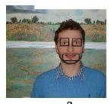

Figure shows the outcome of this feature detection module.

Problem in this process:
Eye box E contains region outside of the face so some spike may be observed on either end of the graph H, corresponding to region outside face.
Solution:
Multiplying H by a double Gaussian with means around the expected location of the eyes and stander deviation of l_{x} will eliminate this problem.

Replacement

Once we have found the two eye boxes containing the left and right eyes and a lip box containing the lips, we can proceed with the ultimate goal of replacing the current features of the original face with the desired features of the model face. The first step is to resize the eye and the lip boxes belonging to the model face such that they fit their appropriate places in the original face, and then superimposing them on the original face. Figure 7 shows the result of this operation. It is evident that this simple replacement will not result in a natural looking face, due to the possible mismatch in the skin colors. The subsequent sections address the problem of blending" the replaced features such that the resulting face will look natural.

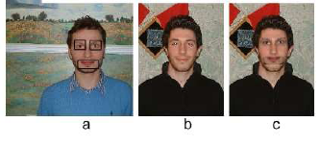
Figure 7

Blending

- P ( x_{i} , x_{j} ) is the probability that pixel ( x_{i} , x_{j} ) constitutes the eye in the original face.
- P(x_{̀i} ʹ, x_{j} ʹ ) is the probability that pixel (x_{̀i} ʹ, x_{j} ʹ ) is part of the desired eye.
- Consider both probability distribution function are known.
- A new eye box N to be constructed from desired eye box D and original eye box O.
- N(i, j, k)= P( x_{̀i} ʹ, x_{j} ʹ ) D(i, j, k)
+ (1 - P(x_{̀i} ʹ, x_{j} ʹ ))(1 - P( x_{i} , x_{j} )) O(i, j, k) + (1 - P(x_{̀i} ʹ, x_{j} ʹ )) P( x_{i} , x_{j} )M_{k}
for k=1,2,3; where N,D,O are all of equal size and M1, M2,M3 are the mean RGB values for the skin colour of the original face.
- When pixel (i,j) in D, D(i,j) is the part of desired eye then N(i,j) must equal the D(i,j).
- When pixel (i,j) for which neither D(i,j) nor O(i,j) is a part of D or O then N(i,j) must be equal with the O(i,j). This ensures that the colour and the texture of the original face are preserved.
- When pixel (i,j) in D, D(i,j) is not the part of the desired eye but in O, O(i,j) is the part of the original eye then N(i,j) must be same with average skin colour of the original face.

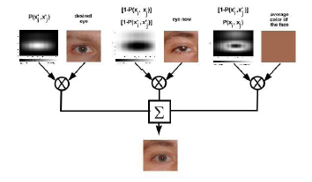
Figure 8: The procedure described above is represented by the figure 8.
- Here it is required to find the value of the P ( x_{i} , x_{j} ) and P( x_{̀i} ʹ, x_{j} ʹ ). The procedure for this described in the following points.
- Let P (xi) is the probability that the pixel in the ith row of the original eye box, O, are the eye pixels.
- P (x_{j}) is the probability that the pixel in the jth column of the original eye box, O, are the eye pixels.
- P (x_{̀i} ʹ) and P (x_{j} ʹ) are the corresponding probability for the desired eye box D.

- The equation for P( x_{̀i} , x_{j} ) will be,

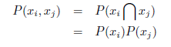
- The equation for P( x_{̀i} ʹ, x_{j} ʹ ) will be,

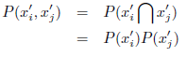

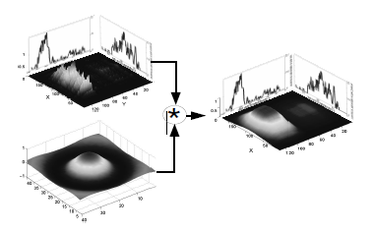

Figure 9

The pdf's derived from above two equations, and the sum of edges in rows and columns as P(x_{̀i} ), P(x_{̀j} ), P(x_{̀i} ʹ) , and P(x_{̀j} ʹ), suffer from one major shortcoming: They consist of discontinuous sharp peaks, and deep valleys between the peaks rather than continues functions of position, which is what we would ideally need if we are to obtain smooth fusion of faces. We have addressed this problem by convolving the pdf's of the above equations by the sinc function. Note that we have not investigated the possibility of using other functions for this smoothing task. Potentially, any other differentiable, slowly changing function, such as a Gaussian, could be used. Figure 9 shows the result of this operation.

Shifting

The following points describing the reason of performing the Shifting:
- Relative position of the eyes in the original eye box, O, and the desired eye box, D, may not be same all the time.
- For example, in D eye is present in the top right corner and in O it is present in the bottom left corner.
- The expression for the N will then produce the total desired eye in the bottom left corner and the upper right corner will become skin.
- This will not look natural.
- Location of the center of the mass of P (xi, x_{j}) and P (x_{̀i} ʹ, x_{j} ʹ) to determine where the eyes are located in O & D. Let x & y coordinate of the center of mass, CM_{x}, CM_{y} for a given PDF could be found in this way.

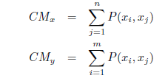

Now there are two ways of making the relative position of the eye in the eye box same. Both are described here.

- In the figure 10 eye in the desired eye box is shifted in the location same as in the original eye box.
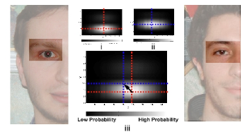
Figure 10

- Here in figure 11the eye boxes are translated. Both of the eye boxes will be located in the relatively same position.
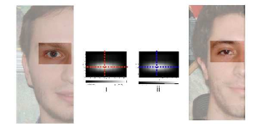
Figure 11

Final Result

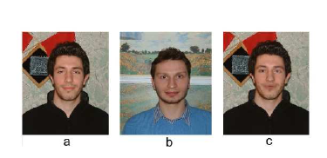
- Figure a is the original face.
- Figure b is the model face.
- Figure c gives the final face where the improvement gains due to the application of blending & shifting after replacement.

Conclusion
In this work we described details of a system that achieves fusion of a face with facial features belonging to another individual -possibly of different skin color. The resulting face looks natural, without discontinuities in color or texture. This system could be used as a tool to predict the outcome of aesthetic maxillofacial surgeries.
This algorithm uses five modules: face detection, feature detection, replacement, shifting and blending. To detect faces, we combine aspects of two well-known face detection algorithms by utilizing the color information as well as using a generic face template. In the facial feature module we have used vertical and horizontal projection of edges in a face to find the exact location of features such as eyes and lips. This information was also used to construct probability distribution functions, used to fuse the replaced features within the original face. While this work targets the problem of facial feature fusion, some of the techniques outlined here could be used in other areas of image processing and fusion. However, there are certain limitations in our system, which need to be addressed.

Reference:
- Face Fusion: An Automatic Method for Virtual Plastic Surgery by Seyed Alireza Rabi, Parham Aarabi. The Edward S. Rogers Sr. Department of Electrical and Computer Engineering, University of Toronto. Toronto, ON, Canada.

- Gonzalez R. Woods. E., Digital Image Processing, Prentice Hall, Second Edition, 2002.

- http://en.wikipedia.org/wiki/Plastic_surgery

